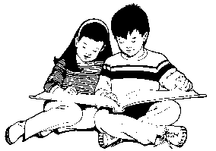 | Burke Basic School
131 E. Southern Avenue, Mesa AZ 85210
Telephone: (480) 964-4602
Fax: (480) 964-6566

School Uniform Polo Order Form

Student Name: ____________________________________________________________
Grade: __________________
Teacher Name: _______________________________________

Quantity | Size | Color | Price Per Shirt | Total
 |  | Red | $ | $
 |  | White | $ | $
 |  | Navy Blue | $ | $
 |  |  | Order Total:$

Available Sizes:
$10.00 Each
Youth Small
Youth Medium
Youth Large
Youth X-Large

$11.00 Each
Adult Small
Adult Medium
Adult Large
Adult X-Large

